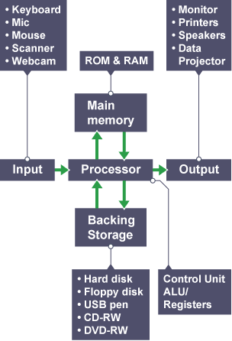

4. Functional view of the computer is given in the figure 4.1. The four main operations of the computer are Controlling, Data processing, Data moving and Data Storing.

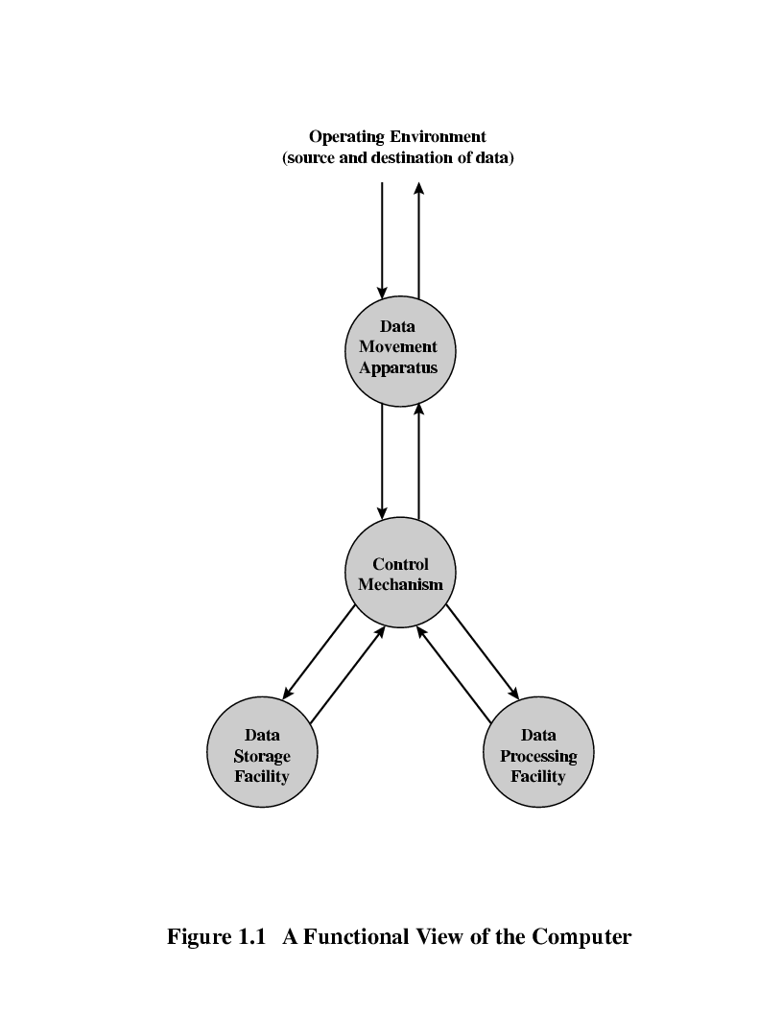Figure 4.1

Explain following operations using the graphical representation of Figure 4.1 with an example for each operation.

Draw the path between circles through the corresponding circle.

1. Data Movement
2. Data Storage from IO
3. Data Processing From IO
4. Data Processing from Storage
5. Data Processing from IO to Storage

6. A scenario for a project explained in bellow.

1. Identify what are the main operations that related to Data Movements, Data Processing, Data Storage and Controlling Process in the system in architecture point of view.
2. Draw the functional diagram for the design of the project.
3. Identify how many groups need to be employ and categories them according to their development process.
4. Identify similar operations for implementation and assign them to each development group of your company.

A scenario for the project

* Department of Disaster Management has a plan to develop web application that use to report the incident occurred at different locations in the Western Province. Following are the examples of possible incidents like Natural Disasters, Road Side Accidents, Fires, and Electrical Breakdown & Leakages etc.
* Authorized incident reporters are issued logging accounts to reports the incident. The police stations, Grama Niladari, Post Office and assigned members from general public will report the incidents.
* Incident reports manger has the total authority to approve the incident to be display in the public web. Incident report manager has a logging that has an authority to see all new incidents, approved incident for the display for the general public.
* Incident report manager has authority to change the threat level and effect of the incident to the general public.
* Once the incident report manager approve the incidents reported, they will appeared in the Map of the Western Province,

This is the expected outcome of the project. Any group can choose different scenario that satisfy the given scope of the above scenario.

Project Requirements

* Administrator Account (Super User). Administrator can create user accounts change the user’s accounts.
* Input data, delete data, manipulating data
* Plotting data on a Google Map, or any other suitable map.
* Making Alerts to relevant users.
* Multiple different ways of viewing the data